**Bug Report**

**Summary:**

When publishing new AD there is no option to select a street when it not a city and after the AD was publish there is no filter filed for city or other options.

**Steps to reconstruct:**

Navigate to "<https://homme.co.il/>" web.

Click on the "Login" button.

Fill Username and password.

Click on the connect button.

Click on "Publish AD" button.

Fill the asset status, city, Street name and house number.

Click on the "Next" button.

Fill the asset floor and all the floor number (if there is).

Fill rooms, terrace and parking number.

Fill the size of the house in square meters.

Select if there is an elevator.

Click on the "Next" button.

Select some added values of the property.

Click on the "Next" button.

Fill the number of payment, the house committee and the taxes cost.

Fill price and select a start day for the contract.

Click on the "Next" button.

Select some images of the asset.

Click on the "Next" button.

Fill the full name and the phone number of the asset owner.

Click on the "Publish AD" button.

Navigate to the "Apartment pool" page.

Search the AD by street name.

**desired Result:**

To be able to fill street name in options that it not cities and to able to search any city or other option.

**Actual Result:**

There is no option to select a street to place that is not a city and there is no option to search an asset by city or any other place only by street name

**Attachments:**

Apartment pool page Ad for an asset in the city Ad for an asset not in the city

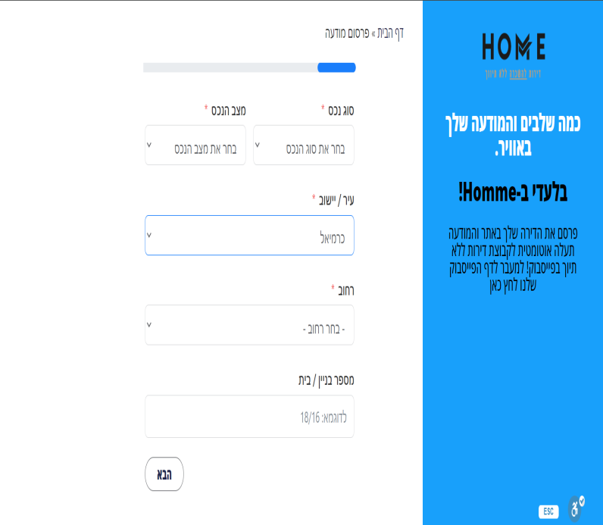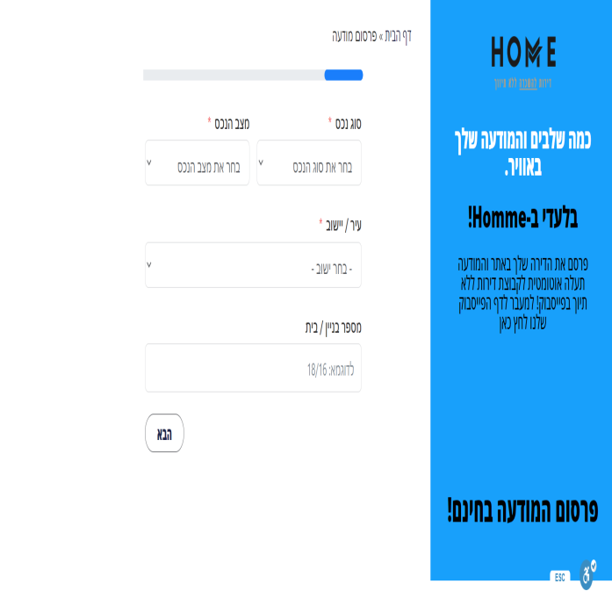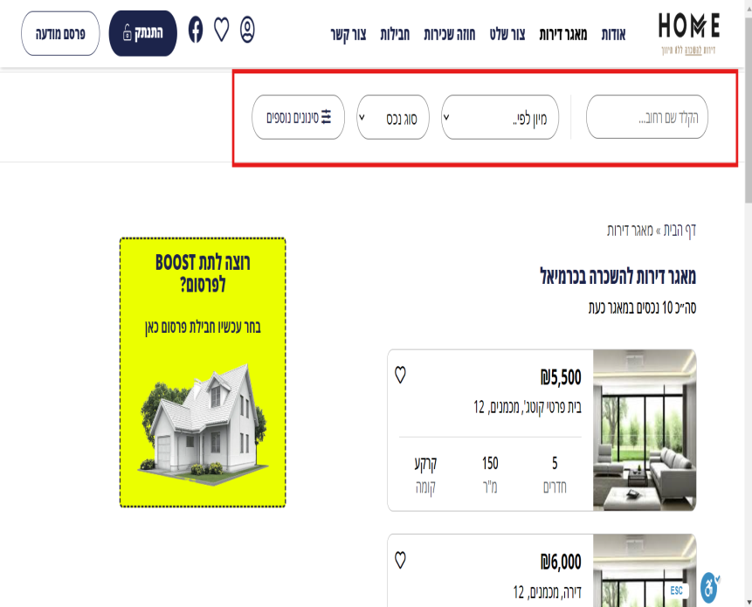

And a video that I'll add to this file.